Retail Demand Forecasting & Inventory Optimization

Week 5 Progress Report

Prepared By:
Soumya Tiwari

Internship Domain:
Data Analytics

Date:
15 July 2026

1. Objective
The objective of Week 1 was to set up the development environment, download and understand the Walmart M5 Forecasting dataset, perform initial data exploration, clean the calendar dataset, and merge the datasets to create a master dataset for future demand forecasting.

2. Tasks Completed
1. Project Setup
Completed the following:
- Created project folder structure
- Created Python virtual environment
- Installed required Python libraries
- Generated requirements.txt
- Initialized Git repository
- Connected project with GitHub
Tools Used
- Python
- VS Code
- Git
- GitHub
- Jupyter Notebook
- VS Code project structure
- GitHub repository

2. Dataset Collection
Downloaded the Walmart M5 Forecasting Accuracy Dataset from Kaggle.
Datasets used:
- sales_train_validation.csv
- calendar.csv
- sell_prices.csv
Stored them inside:
data/raw/
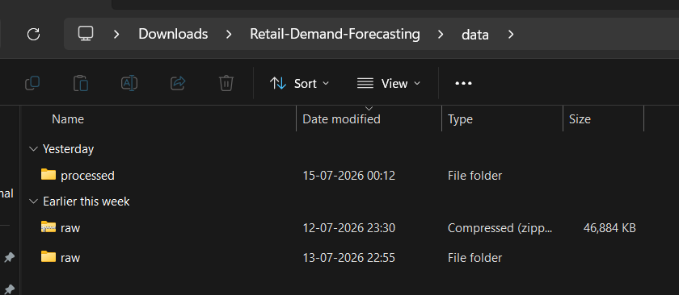
- Dataset folder

3. Data Exploration
Performed:
- Loaded datasets using Pandas
- Checked dataset shape
- Viewed column names
- Verified data types
- Checked missing values
- Checked duplicate records
Observations
- Sales data contains historical daily sales.
- Calendar contains holidays and events.
- Price dataset contains weekly selling prices.
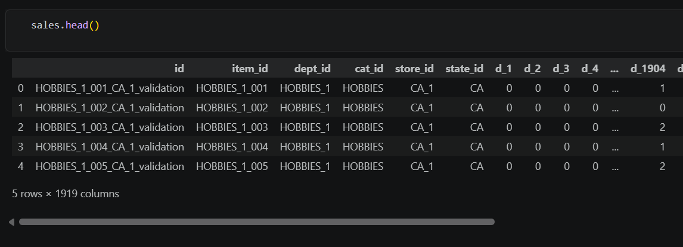 sales. Head()
4. Data Cleaning
Performed:
- Filled missing values in calendar event columns.
- Converted date column into datetime.
- Created:
- year
- month
- day
- weekday
Example:
calendar["date"] = pd.to_datetime(calendar["date"])

5. Data Merging
Converted the sales dataset from wide format to long format using the melt() function.
Merged:
- Sales dataset
- Calendar dataset
- Sell Prices dataset
Created:
master_dataset.csv
Stored inside
data/processed/

6. GitHub Version Control
Performed version control using Git.
Commands used:
git add .
git commit -m "Meaningful commit message"
git push
GitHub repository updated successfully.
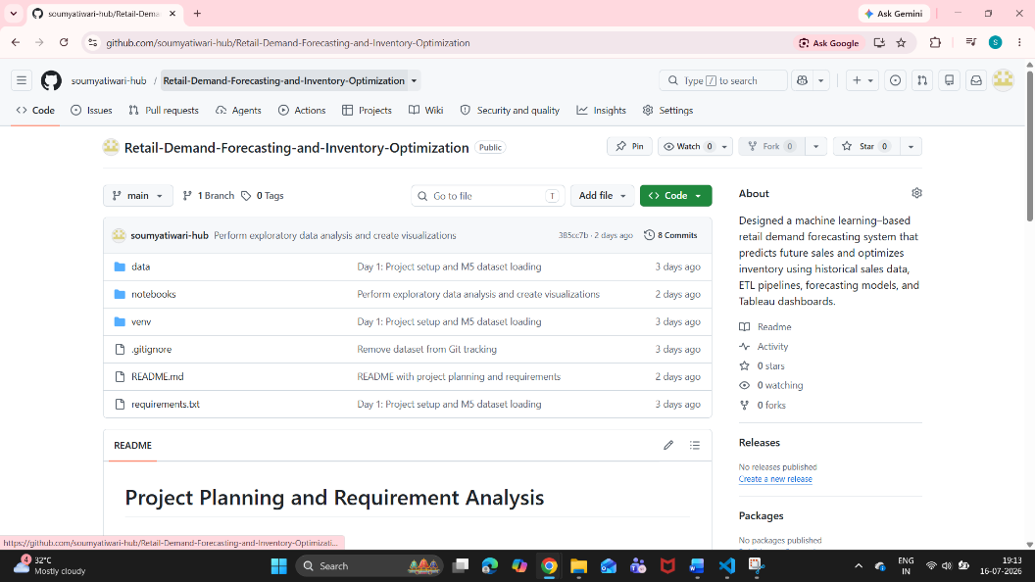
GitHub repository page

3. Technologies Used
Technology | Purpose
Python | Data Processing
Pandas | Data Manipulation
NumPy | Numerical Operations
Jupyter Notebook | Analysis
Git | Version Control
GitHub | Repository Management
VS Code | Development Environment

6. Learning Outcomes
During Week 1, I learned:
- Setting up a Data Analytics project
- Using Git and GitHub effectively
- Loading and exploring large datasets
- Data cleaning techniques
- Dataset merging using Pandas
- Organizing a professional project structure

7. Conclusion
Week 1 successfully established the foundation of the project by setting up the development environment, understanding the Walmart M5 dataset, cleaning and transforming the data, and creating a master dataset. This prepared the project for exploratory analysis and forecasting model development in the following weeks.

